Name ____________________

Total Time: | 50 minutes | 
  ∕50
  ---- %
Total Reading: | 3 minutes
Total Working: | 47 minutes
Weighting: | % of the year.
Equipment: | SCSA Formula Sheet; ½ page notes (A4 one side), CAS calculator; Scientific Calculator
SECTION 1: CALCULATOR FREE
Time: | 30 minutes | Marks for Section 1: | 29 marks
Reading: | 2 minute | Equipment Allowed: | Nil
Working: | 20minutes

1. [7 marks: 2, 2, 3]

Solve for x.

i. x² + 4 = 0 ii. x² + x + 4 = 0 iii. x³ + 9x = 0

2. [3 marks: 1, 2]

For the complex number z = 8 − 3i , find
i. Im(z) ii. |z|

3. [3 marks]

The solutions to a quadratic equation are x = −2 + i and x = −2 − i. Determine the original quadratic equation.

4. [2 marks]

Prove that the product of a complex number and its conjugate is a real number.

5. [9 marks]
Let the complex numbers z₁ = 2 +k i and z₂ = -5 + 12i, where k is a real number.
Determine all values of k if:
i. [Im(z₁)] ² = Re(z₂)

ii. z₁² = z₂

iii.

6. [5 marks]

Use mathematical induction to prove that the sum of the first n multiples of 5 is given by

Name: | ___________________________________________________ |  | Date: ___________
SECTION 2: CALCULATOR ASSUMED
Time: 25 minutes |  | Equipment Allowed: Curriculum Council Formula sheets,  CAS calculator, 1 page of notes (A4 one side)
Marks for Section 2: 21 marks

7. [3 marks]

Using the quadratic formula 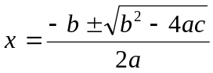 or otherwise, determine the exact solutions to 2x² − 2x + 25 = 0.

8. [5 marks: 1, 2, 2]

If w = 5 − 3i and c = 2 + i determine exactly in the form a + bi
i. c² ii. 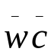 iii. 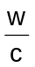

9. [4 marks]

The Argand diagram below shows the complex number z. On the same diagram plot and label the four complex numbers given by 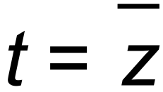 , u = i z , v = i³ z, w = z².
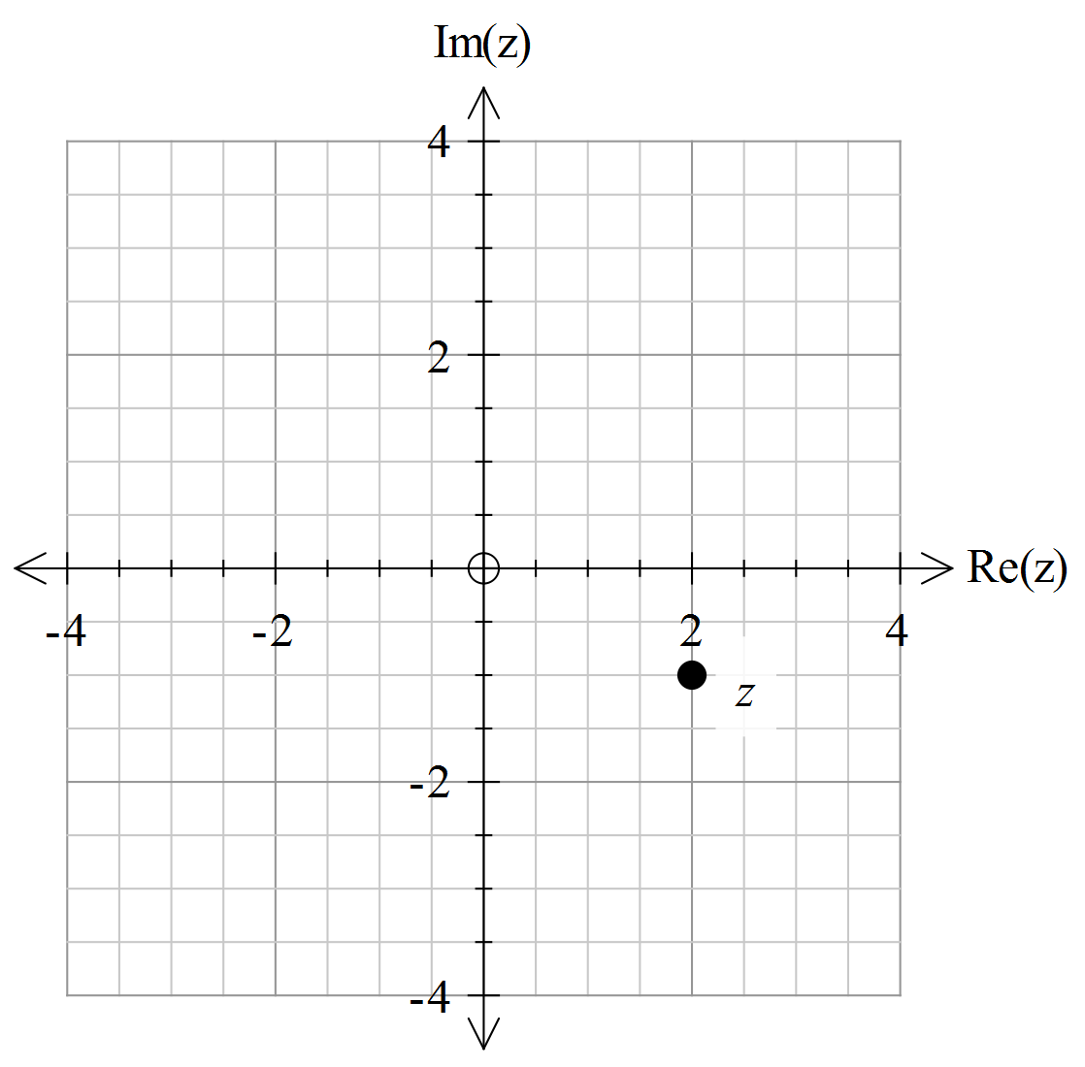

10. [4 marks]

Prove by contradiction that 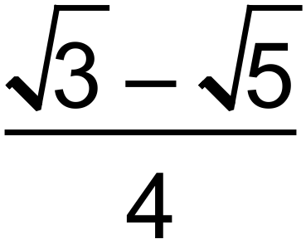 is irrational.

11. [5 marks: 1, 4]

The variables k and m are both positive integers such that m² +3 =2k .

i. Explain why m must always be odd.

ii. Using the fact that an odd integer can be written in the form 2n +1, or otherwise,
prove that k is always the sum of three square numbers.

.

~End of Test ~

